Q1

Q2

Q3

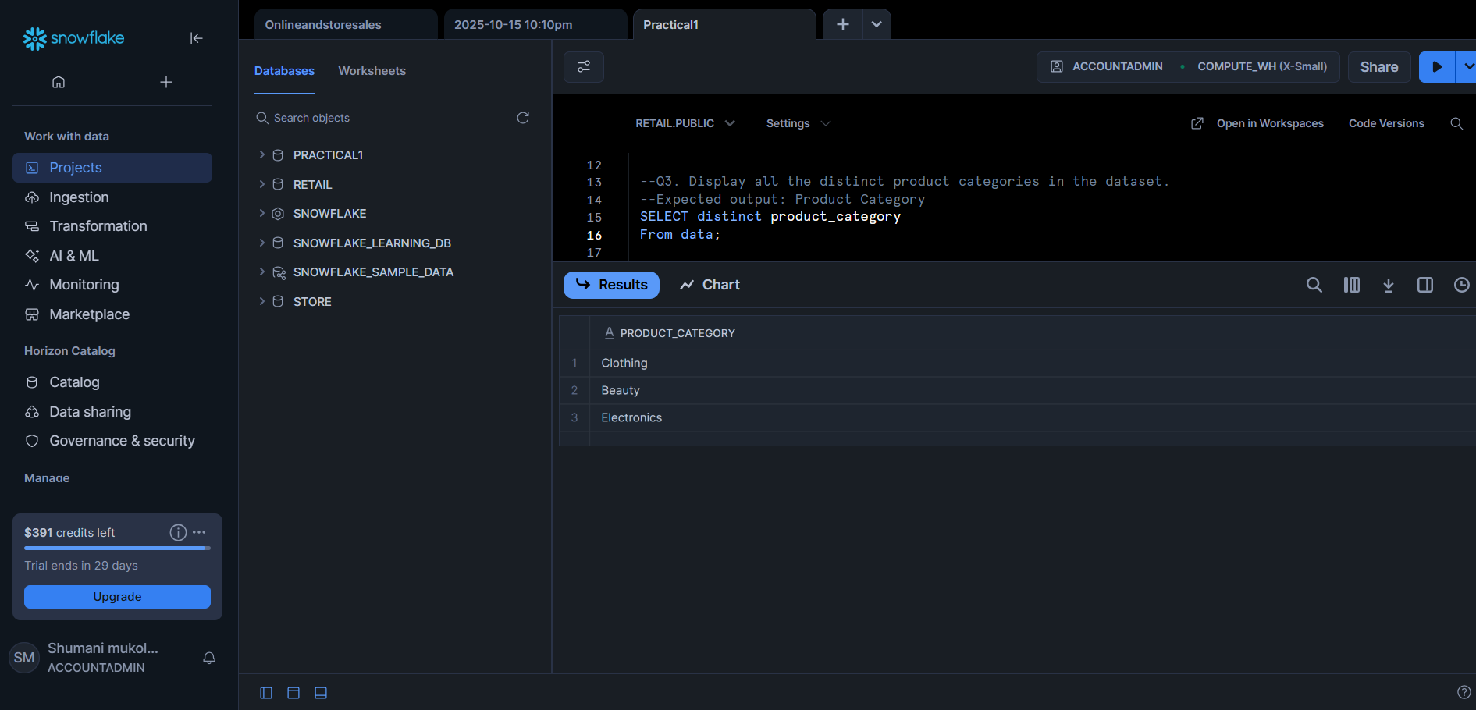

Q4

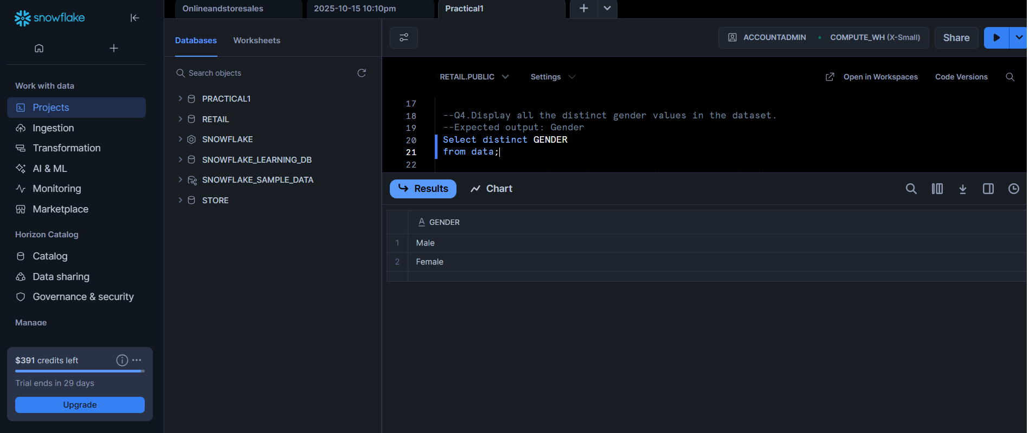

Q5

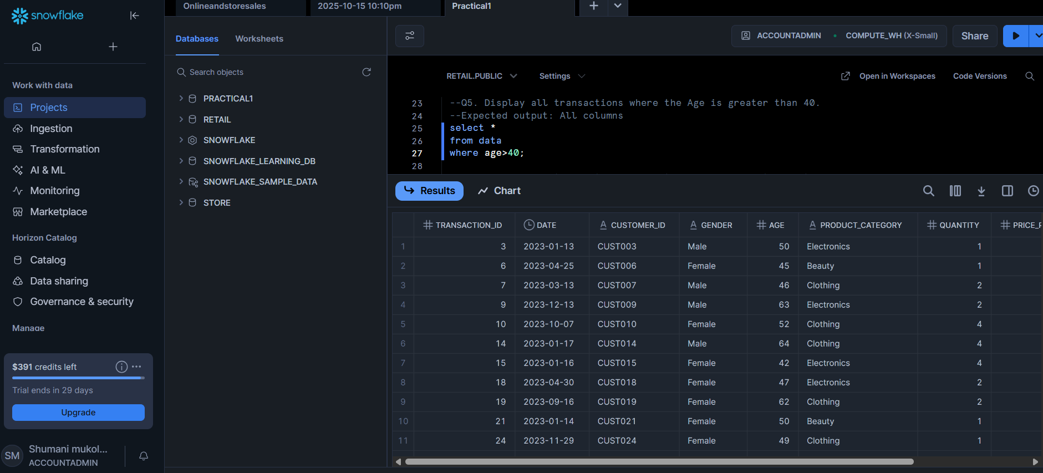

Q6

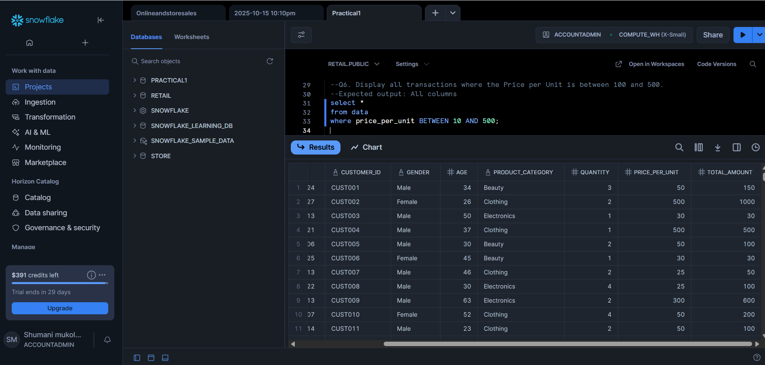

Q7

Q8

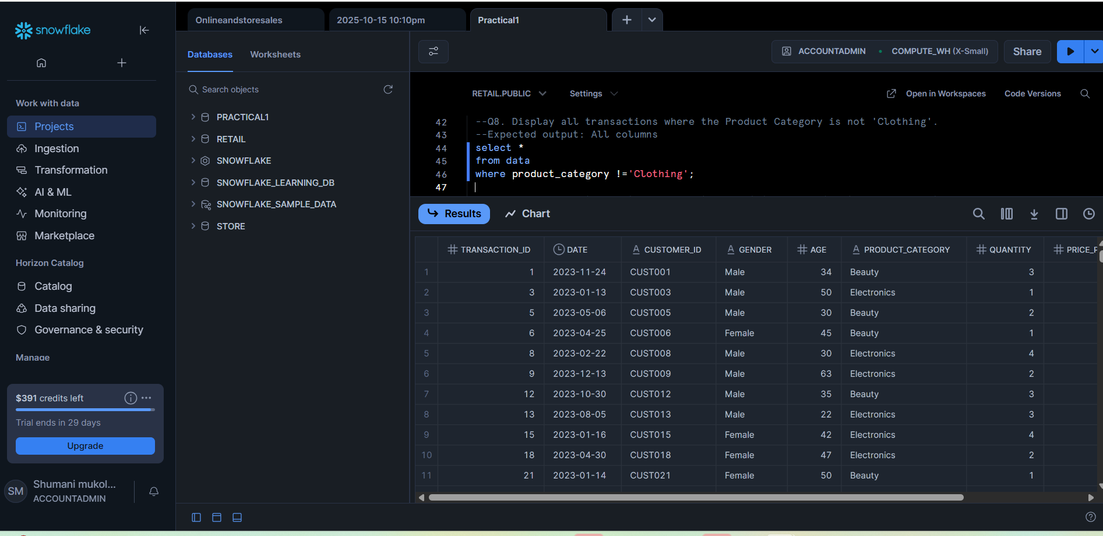

Q9

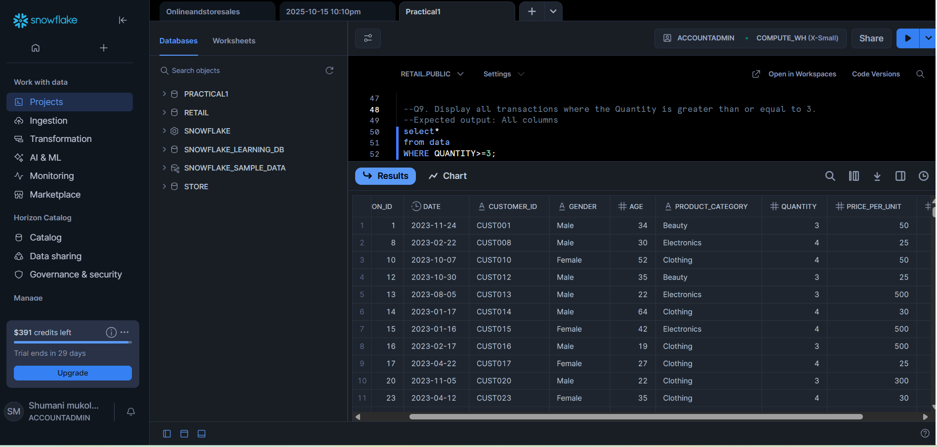

Q10

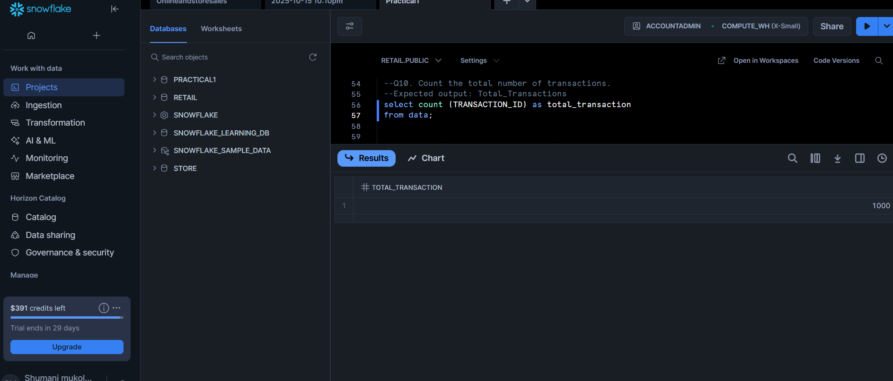

Q11

Q12

Q13

Q14

Q15

Q16

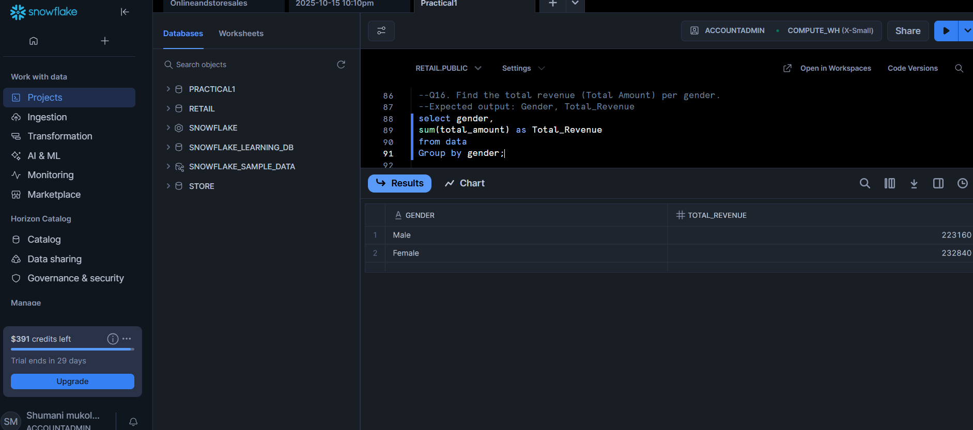

Q17

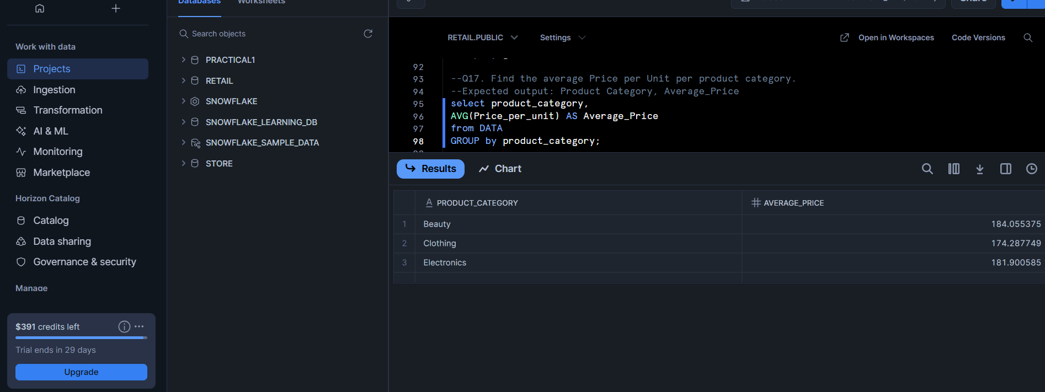

Q18

Q19

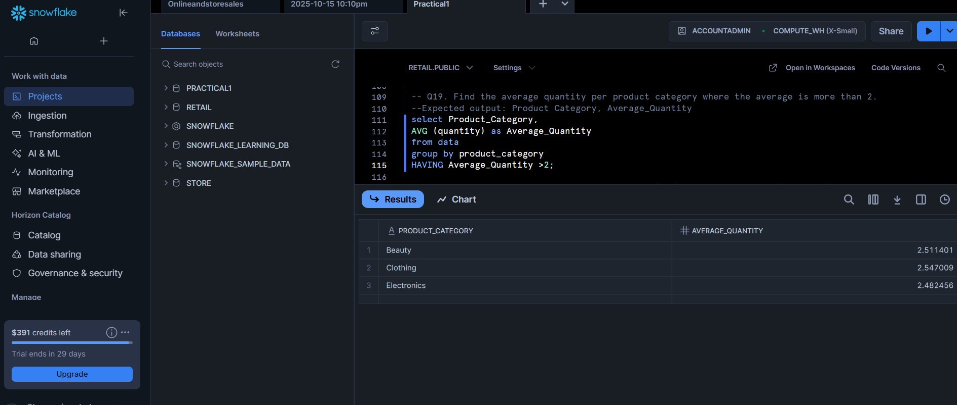

Q20

Q21

